Believing the balga – celebrating an important scientific discovery in WA forests

The Bushfire Front notes that it is nearly 40 years since research scientist Dr David Ward made the momentous discovery that he could date historical bushfires in WA’s southwest forests from scars on the trunks of grass trees (also known by their Noongar name ‘Balga’).
David already knew quite a lot about balga. Firstly they are highly resilient to bushfires, resprouting after even the most fierce fire. Secondly, the balga, unlike a ‘normal’ tree, does not lay down growth rings radiating out from the core of the trunk that mark the passing years. Instead, the growth marks on the stem of a balga show the passage of time in a vertical direction. Balgas grow very slowly, only 2-3 cms in height every year, but a circular mark is left on the stem by each year’s growth. The first mark down from the top is last year, and as you count the rings down the trunk, so you count the passing years – and they can thus be dated.
David noted that if you cleaned away the charcoal and remains of the thatch and other debris from the balga stem, the growth rings became easier to see and count. He also noticed that every so often there was a dark band, which he called a scar. Investigation revealed that these bands were fire scars and represented the occurrence of a bushfire at that spot. Counting annual growth rings down from the top of the tree, Dave was thus able to date the year of the fire. This he confirmed by examination of fire records. To his satisfaction, Dave was able to demonstrate a near-exact alignment between the date of a fire according to counting down the trunk of a grass tree in the bush, to the date of the fire in that part of the forest as recorded in the records.

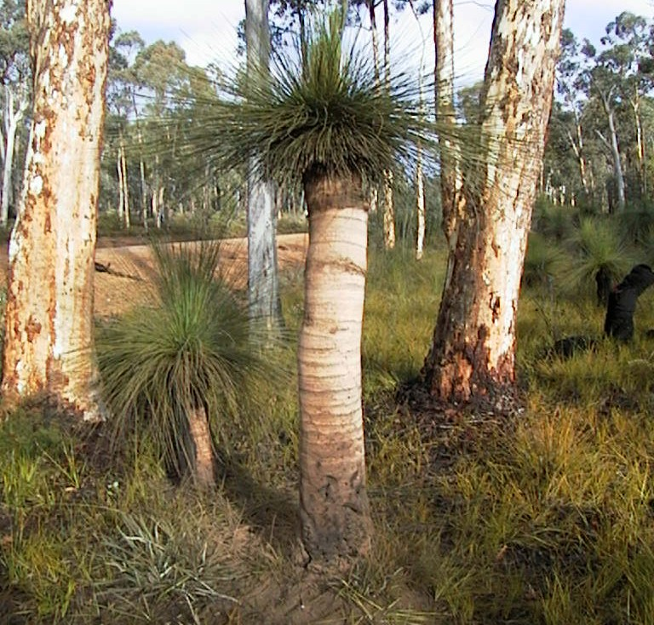
A cleaned balga in the wandoo forest, showing fire scars – the black bands on the stem
Because balgas live for hundreds of years, David then found it was possible to use the fire scars to reconstruct fire history going back to before European settlement. He cleaned and analysed hundreds of balgas, and the message was largely consistent. It demonstrated that most of the drier and drier parts of southwest forests experienced fire on average every 2-4 years. This remarkable evidence was the first time empirical data could be used to support the observations of the early explorers and settlers (as discussed in a hallmark paper by Dr Ian Abbott), all of whom commented on the way Aboriginal people lit up the bush on a regular basis, the result being a mosaic of unburned, lightly burned and more intensely burned areas. These patterns also supported the recollections of Aboriginal Elders whom David consulted. Thus, the whole story came together, with actual historical evidence in the forest reinforcing the observations of humans and their oral and written history.
The Bushfire Front believes that discovery by Dr Ward that fire history could be reconstructed from balgas was a watershed moment in the understanding of bushfire ecology in our southwest forests. It demonstrated that over most of the landscape fire occurred regularly and frequently. This gives us confidence that the forest is well-adjusted to an environment in which fire is a frequent visitor, and that the claims that prescribed fire is “un-natural” and is destroying the forest and its biodiversity are unsubstantiated.

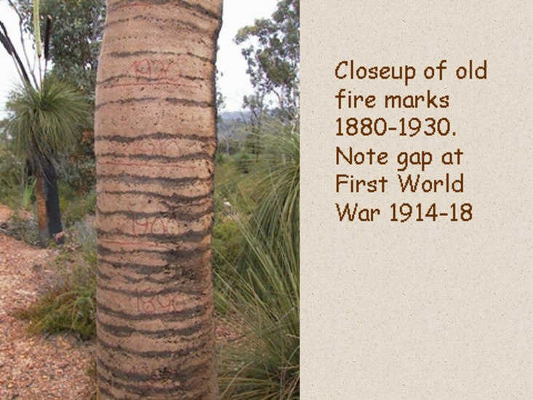

Afterword:
We note with sadness the recent death of Dr David Ward, at the age of 88, after a long illness. Over his exciting life, David had been a soldier in the British Army (a member of the famous Parachute Regiment), a policeman in Africa, a firefighter and then a fire researcher in Western Australia. His first book Our dangerous friend – bushfire philosophy in South West Australia was published in 2022, and his memoir From Policeman to Pyrologist is soon to be published by the Bushfire Front.
Further reading:
Believing the Balga by David Ward and Rick Sneeuwjagt, Landscope Magazine, 1999
Aboriginal fire regimes in South-west Western Australia – evidence from historical documents by Ian Abbott (2003). This is a chapter in the excellent book Fire in ecosystems of south-west Western Australia: impacts and management.

