Fire and Water
How Prescribed Burning Protects
Our Water Supplies
Bushfire Front (WA) paper No 3
November 2025

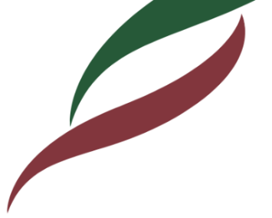
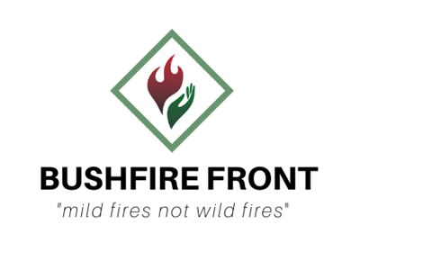

Water sustains all life. A significant proportion of the fresh water for Western Australians comes from our forested catchments, which produce the water for dams and reservoirs. These include the Mundaring, Canning, Wungong, Serpentine, North Dandalup and South Dandalup dams in the northern jarrah forest, and further south, the Logue Brook, Waroona, Harris River and Wellington Dams. Numerous smaller dams in the lower south west provide fresh water for country towns.
All these dams are fed with clean water harvested from catchments of native jarrah, marri, wandoo and karri forests. It is essential to keep the dams free of pollution, whether that be chemical, physical or biological pollution.
Uncontrolled fire is one of the biggest threats to the quality of water which flows from forests into dams. If catchment forests are razed by high intensity bushfire, the result is massive soil erosion with torrents of rain water carrying soil, mud and organic matter down streams and into the reservoirs. If one or more dams need to be taken off-line during summer due to a pollution event like this, meeting peak demand for water becomes a serious problem.
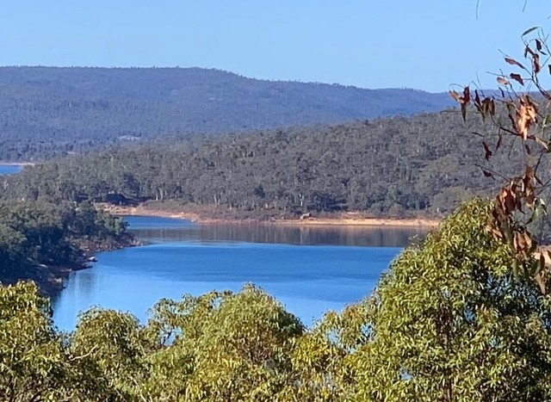
In this paper, two case studies are presented to highlight the risks posed by bushfire to our surface water catchments and the vital role that fuel reduction prescribed burning plays in restricting the spread of bushfire and minimising those risks.

Mundaring Dam, viewed from North Ledge (J Clarke)

- Case study 1: 2005 Perth Hills Fire
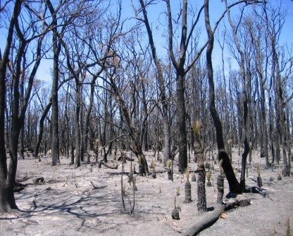
Many Perth residents will remember the afternoon of mid-January 2005 when smoke and ash from an intense bushfire burning in Perth’s hills blanketed the metropolitan area for days on end. The fire was started by an arsonist who lit separate fires in dense bush carrying heavy, long-unburnt fuel. The day was hot, with strong easterly winds. Fire crews were swiftly on the scene, but the fires were already burning through the tree crowns, causing total defoliation, and embers were spotting kilometres ahead.
Under these conditions, an attack on the head-fire was too dangerous, and aerial suppression was ineffective.
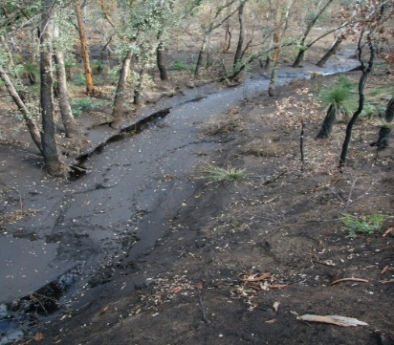
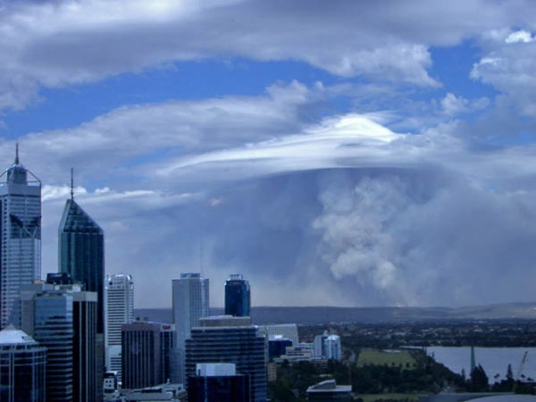
This bushfire threatened Mundaring, Pickering Brook, Karragullen, Araluen, Roleystone and Darlington communities. For five days, more than 1500 firefighters worked tirelessly to contain the flames. It was only controlled when the head-fire reached areas where fuel loads had been reduced by prescribed burning. This intense bushfire burnt through 27,000 hectares of jarrah and wandoo forest on water-supply catchments, particularly the catchment of the Mundaring Weir. Although the cost of managing this bushfire was huge, the recent prescribed burning of areas meant that no lives or homes were lost. However, several firefighters were injured, and the smoke from the bushfire persisted over Perth for a further seven days. Post-fire monitoring showed that terrestrial and aquatic biodiversity was significantly reduced by this high-intensity fire, including the loss of over 1.5 million trees.
Pickering Brook bushfire plume over Perth city 2005
(R Sneeuwjagt)

The potential risks and impacts to water values from the wildfire were:
- short-term increases in surface water run-off and yield,
- increased water cloudiness and colour, and
- increased organic material leading to a decrease in oxygen and discharge of nutrients leading to eutrophication.
The water supply dam which was most at risk was Mundaring the main water source for the goldfields and agricultural regions. Water treatment at Mundaring is by chlorination and fluoridation, not filtration. Turbidity in water reduces the effectiveness of these treatments therefore it was vitally important that dirty water was kept out of the dam to minimise health risks. Swift action had to be taken before the onset of autumn and winter rains including construction of sediment barriers and diversion channels coupled with constant monitoring of water quality and reviewing of water take-off options.
Aftermath of 2005 Hills fire showing (top image) defoliated forest and (bottom image) major impact on streams & all aspects of biodiversity (F Batini, C Terry)
- Case study 2: 2018 Perth Hills Fire
Thirteen years later history appeared to be repeating itself. An arsonist had struck again, and two bushfires were burning in heavy fuels with strong easterly winds and Perth was again blanketed in smoke.
However, since 2013 approximately 60,000 hectares of forest in the Perth hills had been prescribed burned. Thanks to a number of these strategically located areas of reduced fuels this bushfire was contained to just 4,000 hectares. The head-fire and southern flank of the bushfire ran into forest that had been prescribed burnt within the previous three years and was easily and safely contained by ground crews, at a much lower cost. The risk of erosion and pollution entering the hills dams from this fire was minimal.
Perth Hills bushfires in 2005 & 2028
- Conclusion
While some measures can be taken to remediate the effects of unplanned bushfire damage in water-supply catchments, these events highlight the invaluable role prescribed burning plays in mitigating the size and damage caused by destructive bushfires and protecting water supplies.
With population numbers increasing, the forested water catchments are lifelines to not only Perth residents but to people in other parts of the State. It is essential that the prescribed burning program in our south-west forests is maintained to ensure safe and sustained water supplies.

Prescribed burning
What is it and how is it done?

Also known as fuel reduction, controlled, cool or mild burning, prescribed or planned burning aims to reduce fuel loads using fire, at a chosen time and place under weather conditions that will be safe for fire crews and will protect and enhance environmental values. Prescribed burns are carefully planned and may take up to two years from initial selection to completion.

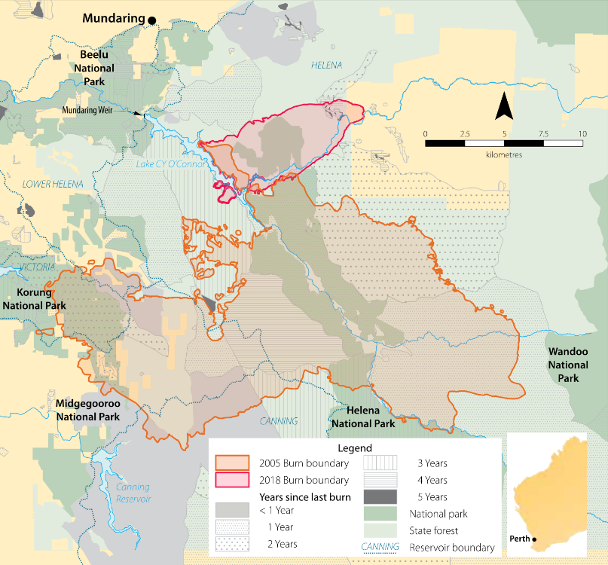
The key steps involved in planning, preparing and conducting prescribed burns, using aircraft for ignition, are:

- Select areas to burn based on fuel ages and risks to life, dwellings, infrastruture and environmental values.
- Evaluate constraints including environmental values, catchment values, flora and fauna, cultural values and neighbours.
- Carry out sampling to establish the actual fuel loads in tonnes per hectare.
- Write prescriptions, considering surrounding risks, by nominating suitable combinations of weather conditions including temperature, relative humidity, wind speed and direction, with the aim of burning 80-85 percent of the areas.
- Prepare burn boundary roads and tracks by grading and clearing away debris.
- On a chosen day when weather conditions match a particular burn prescription, provide the aircraft/helicopter crew with a map of nominated flight-lines and the required spacing between incendiary capsules.
- Dispatch ground crews to the burn, nominate a control point and patrol the boundary to ensure the fire is contained within the selected area.
- Ensure burning trees and logs near the boundaries are extinguished and, once the area is considered safe, dispatch crews home.
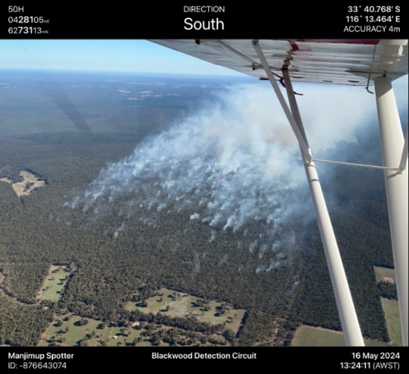
- Monitor burn boundaries over following days as necessary and assess results.
Mild prescribed burn in Blackwood District near Nannup in 2024 (J Evans)

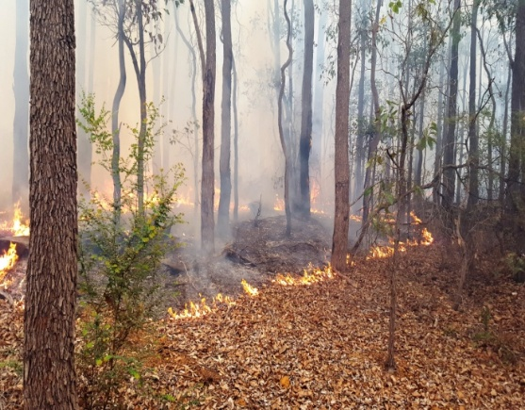
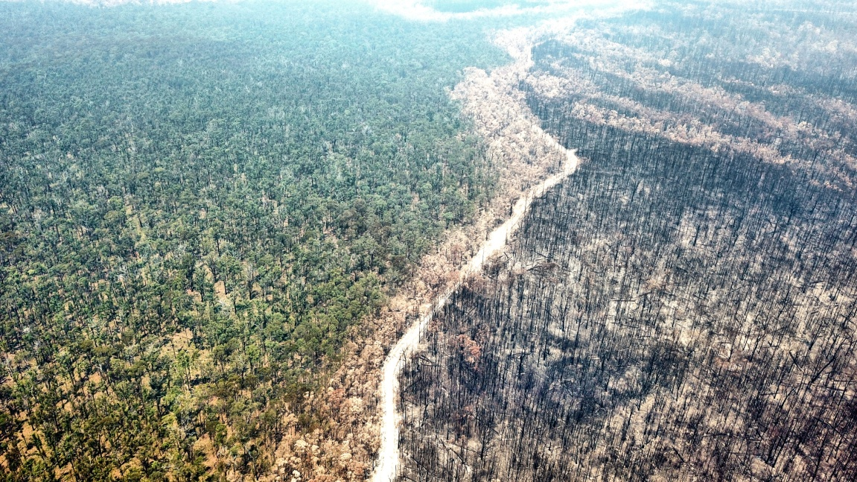
Photo showing the benefit of prescribed burning in slowing the spread of a fierce bushfire in Orbost, Victoria, 2019/20 (Howitt Society)
Pickering Brook, where surrounding forest was prescribed burnt in 2003 and unaffected by the 2005 bushfire (C Terry)

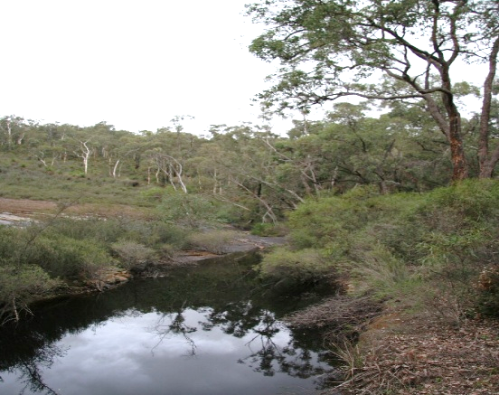
The Bushfire Front comprises trained and experienced fire scientists and bushfire managers. Our aim is to minimise the damage resulting from large, high-intensity bushfires in Western Australia.

A very cool prescribed burn (J Evans)

www.bushfirefront.org.au
info@bushfirefront.org.au

